MACH4METAL

metalworking machinery
Transito 21
6909 DA BABBERICH Netherlands
Tel. +31 (0)316-247123
Fax: +31 (0)316-247956
info@mach4metal.com
www.mach4metal.com

Bank No : 66.52.13.883
IBAN : NL33 INGB 0665 2138 83
BIC : INGBNL2A

CNC Pressbrake Amada HFT 1303
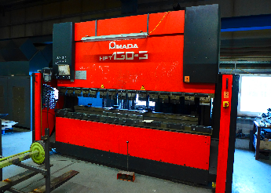

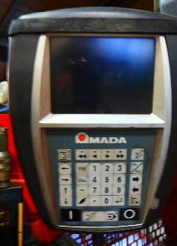

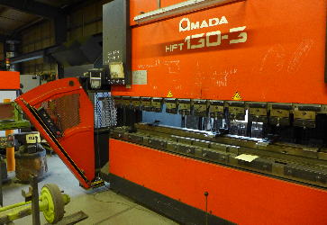

- Make : Amada
- Typ : HFT 1303 CNC
- No : N020406
- Age : 2002

- Max. bending length: 3.140 mm
- Between column : 2.700mm
- Max. force : 130 Ton

- Dis. Beam – table : 470 mm
- Beam stroke : 200 mm
- Table width : 90 mm
- Troth beam : 420 mm

- Approach speed : 100 mm/m
- Bending speed : 10 mm/min
- Return speed : 100 mm/min

- Dimensions
- Length : 4.000
- Width : 2.170
- Height : 2.665
- Weight : 8.750 Kg
- Power : 12.5 kWA

- CNC CD 2000 in 4 Axis Y1 / Y2/X/R
- Machine incl. 3 set tooling

Please Note: The above information has been obtained to the best of our ability and belief from, and from the manufacturers where possible. It is given in good faith, but its accuracy can not be guaranteed. Accordingly, it will not form a representation or constitute contractual terms. We advise you to check any vital details!

